Defining Social Entrepreneurship as a Field via Resource Dependence: Towards Innovation in the Field of Social Entrepreneurship as Integration

Authors Note: After taking several business courses this semester, I became more acquainted with the ways in which entrepreneurship is currently being studied from economics, business, orgs, and sociological standpoints. As such, I’ve found work in these fields I wasn’t yet aware of which may be a better guide for literature review on social entrepreneurship than I had before, specifically the work of Julie Battilana at HBS and Fiona Murray at Sloan, who have worked with hybrid organizations and negotiations literature to speak to social enterprise. As such, next steps for this paper are to rework and integrate their work into the paper as I think their work only helps explain how field theory can be useful here. However, as more people read this, the more they question why I’m using a theory that was originally meant to explain arts and culture for a business topic, so I think I need to address this in my intro better. Any comments about what a hard and fast strategy for publication could be for this paper that requires minimal restructuring (if able) is appreciated!

Cassandra Skinner

May 7, 2020

**Introduction**

Historically, the private and nonprofit sectors in the U.S. have been perceived to play a zero-sum game between doing good for the economy and doing good for society. Though American business has a history of philanthropy, social innovation and social entrepreneurship are gaining recent popularity in rebellion of this perceived false dichotomy as social entrepreneurs argue that they can produce both social and economic value via more environmentally, socially, and economically sustainable business practices. By integrating previously established organizational models, organizations can more effectively capture and produce both cultural and economic capital. Consequent of this revitalized consciousness of doing both social and economic good, nonprofit organizations have taken up models of social enterprise, new business ventures are becoming certified B Corps, and corporations are upping their corporate social responsibility game—in this, social entrepreneurs are effectively defining and shaping the field of entrepreneurship as they strategically capture and employ different kinds of capital to effectively survive and compete with other social entrepreneurs. As such, it appears that the strategic actions of organizations in this space are defined by the relative positions of the other organizations occupying the space in trying to capture or produce similar or different kinds of capital, and in this, organizations strategically position themselves as to maximize their relative likelihood for survival. If this is true, with future research, we could potentially theorize about which types of social enterprises are more likely to succeed and why based on the success with which they position themselves competitively within the field.

In this paper, I propose the following theoretical basis for understanding social entrepreneurship as a field. First, I argue that field actors (organizations) are primarily motivated by survival which they can only accomplish through strategic capital capture and production—in other words, the motivation or mechanism for agents’ decision-making and self-positioning is ultimately resource dependence. Then, organizations in the field of social entrepreneurship continue to compete for resources by identifying with and producing different kinds of capital, and through these processes, they continue to define and shape the field of social entrepreneurship as a whole. Finally, as a result of organizations being resource dependent, we can conclude that the field of social entrepreneurship emerged out of the integration of traditional for-profits and traditional non-profits as traditional for-profit organizations were met with an increasingly socially-conscious consumer demand and traditional non-profit organizations were met with increasing competition for funding—social entrepreneurship is an innovation out of the integration of the previous fields of for-profit and non-profit organizations, and it is likely the field will continue to innovate in similar ways of integration given competitive disadvantages. In identifying, defining, and organizing organizations within the field of social entrepreneurship by their relative positions to each other, we can better understand the competitive advantages and disadvantages which different types of organizations might enjoy or suffer from by occupying their positions within the field, as well as predict when certain competitive disadvantages may result in future innovation. In future work, with case data about organizations’ relative successes and failures within this field, we can potentially measure the relative advantages or disadvantages associated with specific field positions which would reveal some ‘ideal types’ of organizations which occupy specific positions in the field and suggest when innovation might be an organizations’ best option for survival.

While social entrepreneurship and social enterprise as topics of research are gaining traction in the fields of nonprofit and business management, it has yet to be well-addressed in sociological literature. While many sociologists have conducted research around entrepreneurship, few have studied and published about social entrepreneurship. Further, while studies exist with the primary purpose of measuring entrepreneurship and the startup process, social entrepreneurship, particularly in the U.S., lacks such attention as it is a relatively new and ever-evolving field. It is for exactly this reason—that it is a new and ever-evolving field—that I argue a sociological approach is necessary for understanding how and why social entrepreneurship has come about as well as the implications of agents’ actions within this field as they position themselves amongst their peers. Using a sociological approach, we can understand the field of social entrepreneurship as a product of organizational field innovation which continues to evolve as organizations continue to strategically identify with and compete for different kinds of capital. Further, in employing this sociological perspective, there is potential to identify reproduceable, structural determinants for organizational success in the field of social entrepreneurship.

**What is Social Entrepreneurship?**

Thus far, giving the term ‘social entrepreneurship’ a single, useful definition within a single school of thought has proven to be a challenge due to its complicated and fluid nature; social entrepreneurship may look different in different contexts which have different needs and resources. Some organization scholars (Battilana, Sngul, Pache, Model, 2015; Haigh & Hoffman, 2012; Doherty, Haugh, & Lyon, 2014) study social entrepreneurship as hybrid organizations which integrate social and monetary organizational goals into one organizational structure. Anheier (2014) defines social entrepreneurship from a nonprofit organization perspective as “the process of creating value by combining resources in new ways to meet social needs” (p. 92). However, this definition does little to distinguish social entrepreneurship from other forms of entrepreneurship; business literature often defines entrepreneurship similarly, as entrepreneurs are generally thought to be pursuing opportunity by creatively meeting the needs of some population or market (Eisenmann, 2013). Some authors (Peredo & McLean, 2006; Lepoutre, Justo, Terjesen, & Bosma, 2011; Dees, 2001) have attempted to define social entrepreneurship by breaking it down into its parts—the words “social” and “entrepreneurship.” These definitions have in common the need for a positive social cause (social) and innovative, resourceful, and revenue-generating means of achieving such a cause (entrepreneurship) in order to be classified as social entrepreneurship. Social entrepreneurship is often considered an innovative activity to maximize an organization’s revenue stream via ‘earned income’ within the nonprofit sector, however, social entrepreneurship can exist within and between each of the three sectors (public, private, and nonprofit) and encompasses more than just a creative revenue model. Thus, this misconception limits the functional and intellectual potential of social entrepreneurship. Therefore, Dees (2001) defines social entrepreneurs from a more general business perspective as follows:

Social entrepreneurs play the role of change agents in the social sector, by adopting a mission to create and sustain social value (not just private value), recognizing and relentlessly pursuing new opportunities to serve that mission, engaging in a process of continuous innovation, adaptation, and learning, acting boldly without being limited by resources currently in hand, and exhibiting a heightened sense of accountability to the constituencies served and for the outcomes created. (p. 4)

This definition paints a more vibrant picture of the social entrepreneur and his or her roles, but leaves to the reader’s imagination what terms like ‘value,’ ‘relentlessly,’ ‘boldly,’ ‘constituencies,’ and ‘outcomes’ may mean in context while failing to convey the significance of context and restraint in shaping one’s social entrepreneurship. Another proposed definition of a social entrepreneur is “a mission-driven individual who uses a set of entrepreneurial behaviors to deliver a social value to the less privileged, all through an entrepreneurially oriented entity that is financially independent, self-sufficient, or sustainable” (Abu-Saifan, 2012, p. 25). This definition, though, only allows those who do business with or for the ‘less privileged’ and those beyond the financially-dependent startup phase to be labeled as social entrepreneurs. In order to study social entrepreneurship as field, though, I need to use a definition which captures all possible kinds of social entrepreneurship. Therefore, I use Lane’s (2012) broad definition of social enterprise to guide the bounding and analysis of social entrepreneurship: “any business model that, to a significant degree, has a mission-driven motive…the mission-driven motive may be primary and the profit motive may be secondary, or vice versa” (Lane, 2012, p. 18). Overall, these definitions are generally successful in portraying the social entrepreneur as one who responds creatively to a social need. However, these definitions do little to identify the specific unique characteristics of social entrepreneurship (including its innovative applicability within and between sectors, allowing for increased intra- and inter-sector collaboration) which make it creative, successful, and sustainable. Particularly, these definitions fail to emphasize the importance of multi-sectoral and multi-level systems significance, organizational and social sustainability, and context. Perhaps this lack of specificity in its definition allows for more fluidity and flexibility in categorizing new endeavors as socially entrepreneurial, but functionally, a unified understanding of social entrepreneurship and its consistently effective components is essential to its practice.

**Observing Social Entrepreneurship**

As mentioned previously, social entrepreneurship can occur in any sector and includes any socially-benevolent, business-like initiatives. This makes observing social entrepreneurship as a whole to make generalizations about it difficult in that measures of social entrepreneurship in different sectors can and should be different.

To operationalize social entrepreneurship, a few authors have created taxonomies of social entrepreneurship for reference. Dees (1998) first conceptualized the Social Enterprise Spectrum illustrates how the motives, methods, and goals of a social enterprise’s key stakeholders change as the enterprise’s model moves between being purely philanthropic and purely commercial. For example, beneficiaries of a social enterprise which is purely philanthropic might pay nothing while those of a social enterprise which is purely commercial might have to pay market prices. In the middle of this spectrum, there might be subsidized rates, or a mix of beneficiaries who pay or pay nothing depending on financial circumstances. Another, more refined example of a social enterprise taxonomy is that of the “social enterprise zoo” (Figure 1) which explains social enterprise as “containing distinctly different types of animals which seek different things, behave differently from one another, and indeed may (or may not) interact with one another in both competitive and complementary ways” (Young & Lecy, 2014, p. 1320). This metaphor categorizes social enterprises into six major categories: for-profit business, social businesses, social cooperatives, commercial nonprofit organizations, public-private partnerships, and hybrids, each of which reside at the intersection of commercial activity and a social mission.

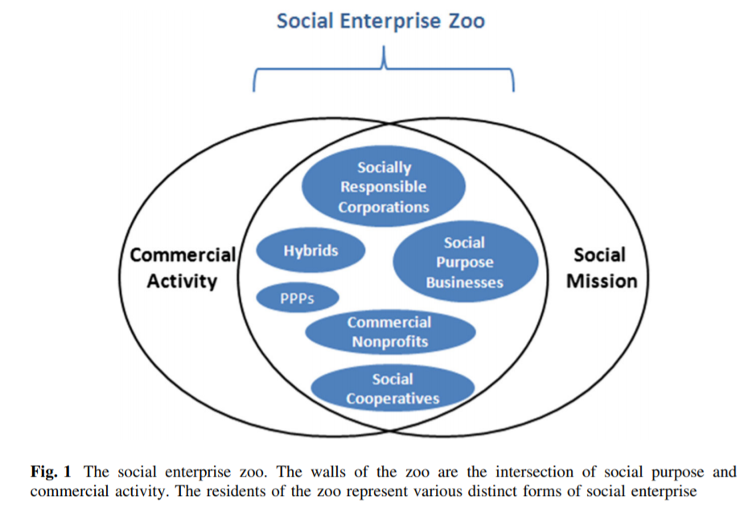

Figure 1. The Social Enterprise Zoo from Young & Lecy 2014.

Private organizations have built upon the social enterprise zoo metaphor and worked to define and taxonomize social enterprise, as well. Virtue Ventures LLC defines social enterprise as “any business venture created for a social purpose--mitigating/reducing a social problem or a market failure--and to generate social value while operating with the financial discipline, innovation and determination of a private sector business” (Virtue Ventures LLC, 2017). They conceptualize social entrepreneurship on a ‘hybrid spectrum’ (Figure 2) which spans from purely mission-driven on the left to purely profit-driven on the right, in which traditional nonprofit organizations are purely mission-driven and traditional for-profit companies are purely profit-driven. Social entrepreneurship, then, is what lies within these two ends. Virtue Ventures LLC includes, from left to right, nonprofits with income-generating activities, social enterprises, socially responsible businesses, and corporations practicing social responsibility (2017). This model is useful in that it provides an ordered categorization of different socially-entrepreneurial organizations from the traditional nonprofit to the traditional for-profit.

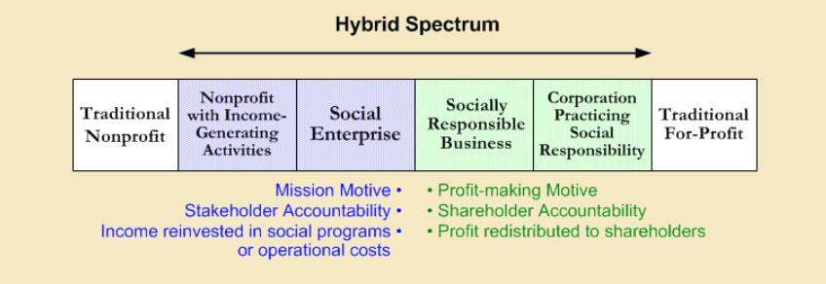

Figure 2: Social Entrepreneurship Hybrid Spectrum by Virtue Ventures LLC.

While the nonprofit and private sectors are not the only sectors in which social entrepreneurship can thrive, they are the sectors in which social entrepreneurship today is most prominent. As previously mentioned, a general decrease in trust in government and thus, decreasing access to public funding, has created a highly competitive environment for the public and nonprofit sectors. The general market—specifically, millennials—is also increasingly interested in buying from socially responsible companies (Landrum, 2017). Therefore, social enterprises today predominantly take the form of nonprofit organizations with a creatively diverse revenue portfolio, private companies with social responsibilities built into their business models, often in the form of B-Corps, or corporate investments in entrepreneurship for social responsibility.

**What is Field Theory?**

Field theory is a Bourdieusian approach to relationally studying social structure and culture. First and foremost, it assumes that more important than the topic of sociological inquiry is the positioning of the topic within a certain space and in relation to other things. Consequently, it conceptualizes that the actions of individuals and institutions are internally compulsive and observable in relation to each other and the ‘spaces’ around them, and the relational components of these spaces are conceptualized as ‘social fields.’ Pierre Bourdieu (1993) in “The Field of Cultural Production” explains his theory of social fields regarding the cultural production of art and literature within the space of sociality and the economy in which the social field is the literary or artistic field and the space or context is a given time period and society. He explains that studying a phenomenon using field theory is a task “of constructing the space of positions and the space of the position-takings in which they are expressed” (Bourdieu, 1993, p. 30). He explains the basis of field theory as follows:

The science of the literary field is a form of *analysis situs* which establishes that each position…is subjectively defined by the system of distinctive properties by which it can be situated relative to other positions; that every position, even the dominant one, depends for its very existence, and for the determinations it imposes on its occupants, on the other positions constituting the field; and that the structure of the field…is nothing other than the structure of the distribution of the capital of specific properties which governs success in the field and the winning of the external or specific profits which are at stake in the field (p. 30).

In defining social phenomena and their fields regarding not only their relation to contextual space but also their distribution of capital, Bourdieu lays out a landscape upon which to simultaneously observe both the social phenomenon’s position within a context and the implication of said social phenomenon’s positioning. As Hilgers and Mangez (2014) explain, “it is the structure of the relations constitutive of the space of the field which determines the forms that can be assumed by the visible relations of interaction and the very content of the experience that agents may have of them” (p. 8). In other words, social structures are made up of the relationships between interactions, and this structure in turn influences both the relationships between interactions and the content of these interactions which are experienced by individuals. Bourdieu’s foundational visualization of a social field can be found in Figure 1 and Hilgers and Mangez’s adaptation of Bourdieu’s visualization can be found in Figure 2.



Figure 1. Bourdieu’s conceptualization of fields. Box 1 is the field of class relations, Box 2 is the field of power, and Box 3 is the literary and artistic field (or field of interest).

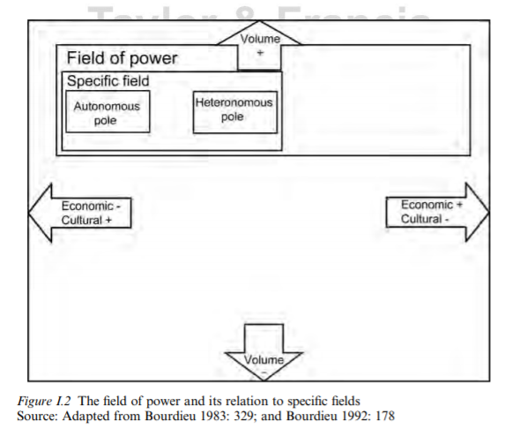

Figure 2. Hilgers and Mangez’s adaptation of Bourdieu’s fields.

In both figures, it is clear that within one larger, broader field of sociality lies the field of power, and within the field of power lies the specific field of interest. Each field is polarized in such a way that indicates either more or less of something given an item’s position within the field. In the broader field of society, there is either more or less capital; in the field of power, there is either more or less power; and in the specific field of interest, there is either more or less autonomy. This is also apparent in Rodney Benson’s (1999) take on Bourdieu’s field theory. All social fields share similar structures of binary oppositions between the dominant and dominated, between economic and political capital and cultural capital. Benson explains that this ultimately results in societal division between the economic (heteronomous) and cultural (autonomous) poles in which heteronomous poles are represented by, acted upon, or driven by forces external to the field of interest while the autonomous poles are represented by, acted upon, or driven by the specific capital unique to the field of interest. He explains that “in the scientific field autonomy means that scholars are able to pursue research and then be judged by their peers according to standards based purely on scientific reason,” as opposed to economically-driven standards (Benson, 1999, p. 465). He goes on to say the following:

In Bourdieu's model, total domination exists when one field dominates all others and thus there exists only one acceptable "definition of human accomplishment" for the entire society. A field's autonomy is to be valued because it provides the pre-conditions for the full creative process proper to each field and ultimately resistance to the "symbolic violence" exerted by the dominant system of hierarchization” (p. 465).

In this, Benson is stressing the importance of autonomous cultural production by the field of interest—a field’s autonomy is what allows the field to create new and valuable cultural ‘objects’ which prevent the field from being completely consumed by and thus, controlled by and indistinguishable from the field of power. With these conceptualizations of field theory, we can conceive of social entrepreneurship as a field itself comprised of the fields of civil society, power, and social production.

**Social Entrepreneurship as a Field**

The goal of social entrepreneurship is to combine the production of social good and economic capital into one business model. Therefore, to conceive of social entrepreneurship as a field, I break it into its conceivable parts as aforementioned in the Hybrid Spectrum: traditional nonprofit organizations, hybrid nonprofits, private social enterprises, corporations conducting corporate social responsibility, and traditional for-profit corporations. Social entrepreneurship can be thought of along Bourdieu’s distribution of cultural and economic capital production (Figure 3). Where an organization falls along this spectrum is indicative of their relative cultural and economic capital productions in relation to other types of social entrepreneurship. On the far left of the spectrum falls the ideal type of cultural capital production which costs economic capital (like traditional nonprofit organizations), and on the far right is the ideal type of economic capital production at the cost of cultural capital (like traditional for-profit corporations). That which falls in between in is considered social entrepreneurship, and explanations of each of these types are to follow my field analysis of social entrepreneurship.

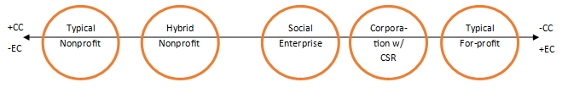

Figure 3. Types of social entrepreneurship along Bourdieu’s distribution of cultural and economic capital production.

In expanding this distribution to include Bourdieu’s other fields, I created the visualization in Figure 4. As helping or business organizations can only exist in a position of power over those who need helping, each of the organizations on the Hybrid Spectrum are situated within the field of power. However, as traditional nonprofits rely on the donations of those in civil society, they do not completely reside within the field of power. Within the field of power resides (mostly – except where traditional nonprofits do not reside in it) what I call the field of social production—this field represents the social good-doing which occurs within the field of power. Traditional nonprofits, hybrid nonprofits, and social enterprises all reside entirely in this field, but corporations practicing corporate social responsibility only partially reside in it as their goals for social good are only secondary, if not instrumental to, their goals for making profit. Traditional for-profit corporations reside completely outside of the field of social production in that their primary and only goal is to make a profit, and this is often at the expense of social good. In this conceptualization of social entrepreneurship, we can see both the relations between the types of social entrepreneurship and their respective consequences for economic and cultural capital.

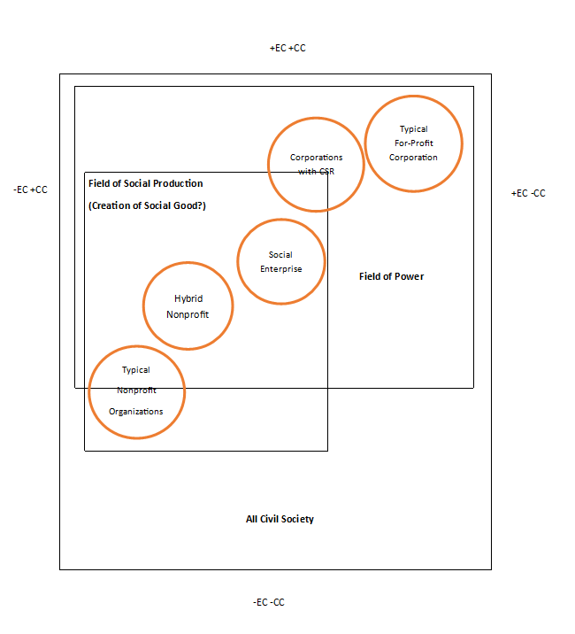

Figure 4. Types of Social Entrepreneurship in one possible conceptualization of them using Bourdieu’s field theory.

However, the very idea of social entrepreneurship is somewhat counterintuitive to Bourdieu’s distribution of economic and cultural capital—social entrepreneurs believe that social good (read here, cultural capital) need not come at the direct expense of economic capital. Instead, the concept of social entrepreneurship was developed as a way for socially-conscious entrepreneurs to, in essence, have their cake and eat it, too. Therefore, I further reconceptualize this distribution as a plane, as seen in Figure 5, in which organizations fall somewhere within the perpendicular distributions of economic and cultural capital. I believe this creates an even better illustration of the relations of each type of social entrepreneurship.

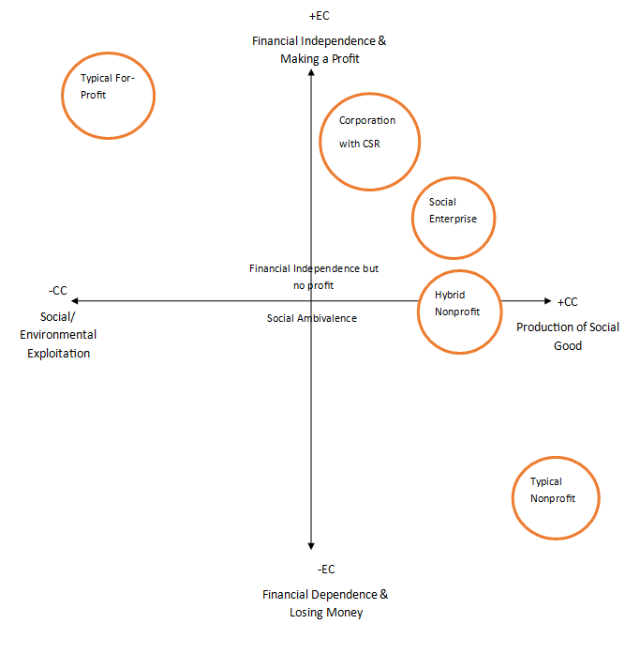

Figure 5. Types of social entrepreneurship visualized via a reconceptualization of Bourdieu’s distribution of economic and cultural capital.

**Types of Organizations within the Field of Social Entrepreneurship: Understanding Organizational Behavior via Resource Dependence**

Pfeffer and Salancik (2003) explain that organizations ultimately behave to maintain their survival. In order to survive, organizations require resources. There are primarily two ways in which organizations try to maximize their resources: either change the organization or its structure to enable increased resource capture within its current environment or change the environment or narrative around the resources which organizations need to survive. Both initiatives to maximize resources require power, which is itself a resource.

I argue that different types of organizations within the field of social entrepreneurship are evident of organizations within this field utilizing both of these strategies to maximize resources, specifically cultural and economic capital. If an organization began with a profit motive (traditional for-profit), it moves toward socially-conscious activities to maximize more cultural capital (company with CSR). If the organization began with a social motive (traditional non-profit), it moves toward commercialization to maximize cultural capital (hybrid non-profit). Following are explanations of the ways that different organizations maximize cultural capital, economic capital, or both, and consequently, their respective placements within the field of social entrepreneurship.

*Traditional Nonprofit Organizations*

Traditional nonprofits depend on donations, grants, and government monies which they do not produce themselves for their operation. Their primary purpose is to create social good, but they do so at the expense of civil society’s economic capital, putting it slightly outside the field of power and into the field of civil society as seen in Figure 4.

*Hybrid Nonprofit Organizations*

Nonprofit organizations—organizations generally expected to solve social problems where the government cannot—are especially hurting for funding as a result of decreased public funding. Dees (1998) explains the following:

Nonprofit organizations have traditionally operated in the so-called social sector to solve or ameliorate such problems as hunger, homelessness, environmental pollution, drug abuse, and domestic violence. They have also provided certain basic social goods-such as education, the arts, and health care-that society believes the marketplace by itself will not adequately supply. (p. 56)

Therefore, a lack of funding for nonprofit organizations may serve as a social problem itself. As previously mentioned, social entrepreneurship is often misinterpreted as existing solely in the nonprofit sector as a means for diversifying revenue models to increase an organization’s economic viability. While this is certainly not the only characterization of social entrepreneurship, it is indeed one vehicle of social entrepreneurship as nonprofits creatively navigate their needs and resources to solve their funding problems and gain more economic capital: “faced with rising costs, more competition for fewer donations and grants, and increased rivalry from for-profit companies entering the social sector, nonprofits are turning to the for-profit world to leverage or replace their traditional sources of funding” (Dees, 1998, p. 55). Dees (1998) explains that this shift of focus by nonprofits from purely philanthropically- and/or publicly-funded revenue models towards commercialization has resulted in a ‘Social Enterprise Spectrum’ upon which social enterprises may be classified (Dees, 1998).

The Social Enterprise Spectrum illustrates how the motives, methods, and goals of a social enterprise’s key stakeholders change as the enterprise’s model moves between being purely philanthropic and purely commercial. For example, beneficiaries of a social enterprise which is purely philanthropic might pay nothing while those of a social enterprise which is purely commercial might have to pay market prices. In the middle of this spectrum, there might be subsidized rates, or a mix of beneficiaries who pay or pay nothing depending on financial circumstances. While nonprofits generally are not turning to purely commercial motives, methods, and goals, they are increasingly having to adjust their funding and sustainability models from being purely philanthropic towards commercialization. The Green for All Youth Employment and Leadership Ladders Working Group is an organization “comprised of leading experts and practitioners working to create green career and postsecondary pathways for our nation's low-income and disconnected youth” (Green For All, 2012). In thinking about social entrepreneurship as a means to increase economic opportunity for disadvantaged youth, The Green for All Youth Employment and Leadership Ladders Working Group adds to Dees’s concept by emphasizing that nonprofits which turn to non-traditional methods of funding supplement rather than replace philanthropic and public funding with commercialized funding sources.

Examples of nonprofits, which either began as a mix of philanthropic and commercialized models or have shifted into a mix (often known as organizations with a triple bottom line) come in all sizes. Social enterprise nonprofits can be range from large, national thrift stores like Goodwill Industries and the Salvation Army, to small community-based nonprofits like Linc Up and Urban Roots in Grand Rapids, Michigan (Spooner, 2016; Dewey, 2015). Organizations like Goodwill and the Salvation Army accept monetary and product donations and apply for grants like any nonprofit organization does, but what makes them social enterprises is that they integrate a commercial thrift store revenue model into their overall funding model to help fund workforce development and homelessness alleviation programs which make meaningful social impacts in the communities they serve. In diversifying their funding portfolios, they make themselves more sustainable and impactful. On a smaller scale, Linc Up and Urban Roots integrate a food service model into their impact models. Linc Up functions as normal restaurant, but it employs those in need in the community to increase individuals’ work experiences and connect them to workforce development resources to help alleviate unemployment and poverty in Grand Rapids. Urban Roots uses farming, community garden, and farmers market models to help educate and empower community members around food justice by involving them in the food-growing process; the money Urban Roots makes from selling the food it grows is being used to fund online classrooms and sustain a local food source in Grand Rapids (Dewey, 2015). Such innovative funding models are proving to be sustainable for nonprofit organizations large and small while they are also making social impacts in the communities they serve. As hybrid nonprofit models are trying to be more financially independent while maximizing social good, they are producing cultural capital while trying not to lose as much economic capital as traditional nonprofits in doing so. Therefore, they are creating more economic capital than traditional nonprofits, but potentially at the cost of some cultural capital in comparison, and thus are positioned further right than nonprofits as seen in Figures 4 and 5.

*Private Social Enterprises*

The volume of social enterprises in the United states has increased significantly throughout the past decade. Approximately “60 percent of U.S. social enterprises were created in 2006 or later, with 29 percent created since 2011,” and about “31 percent are regular ‘C’ corporations or LLCs” (Thornley, 2013). Social enterprises have been estimated to account for about $500 billion, or 3.5 percent of the total US GDP (Thornley, 2013). Often, private social enterprises are small companies which employ fewer than 100 people—only about 8 percent of social enterprises employ more than 100 people (Thornley, 2013). They can also exist as B-Corps, or “for-profit companies certified by the nonprofit B Lab to meet rigorous standards of social and environmental performance, accountability, and transparency” (B Lab, 2017). These social enterprises focus on a broad range of domestic and international social issues. It is estimated that about “20 percent are generating impacts in the area of U.S. economic development; 16 percent are focused on workforce development; 12 percent are targeting energy and the environment; 11 percent are in education; and just 7 percent are working internationally” (Thornley, 2013).

A rich environment for economic investment and opportunity for positive social impact, the U.S. has become an incubator for private social enterprises. Fairbrothers and Gorla (2012) report, “‘on the surface, many social enterprises look, feel, and even operate like traditional businesses…but looking deeply, one discovers the defining characteristics of the social enterprise: mission is at the center of business, with income generation playing an important supporting role.’” Therefore, private social enterprises design their business models just as any other business would, but the key differentiator is the main goal of social impact instead of profit, where profit is just another means of achieving that goal.

Successful examples of private social enterprises are TOMS Shoes, Warby Parker, and Women’s Bean Project. TOMS shoes revolutionized the ‘buy one, give one’ business model with their shoe business, becoming one of the most successful social enterprises to date. Now, TOMS Shoes invests in social entrepreneurship via TOMS Social Entrepreneurship LLC and its Social Entrepreneurship Fund (TOMS Shoes LLC, 2017). Warby Parker follows a similar ‘buy one, give one model” but with glasses. Additionally, a percentage of Warby Parker revenue is used to train people to administer basic eye exams and sell glasses and fund vision care and glasses for school-age children in their classrooms (Warby Parker LLC, 2017). There has been pushback on such “buy one, give one” models, though, as some critics claim that ‘giving’ in any way when trying to alleviate poverty can be more detriment than help: “the model can create dependency, sap local initiative, kill demand for local businesses, and make developed world buyers of one-for-one products complacent about taking other action to address social needs” (The One-for-One Business Model, 2015). However, social enterprises with more programmatic and educational social goals are becoming more prevalent, too.

The Women’s Bean Project “hire[s] women who are chronically unemployed and we teach them to work by making nourishing products that we sell across the US through some of the country’s largest retailers,” and “tucked inside this business is a human services organization designed to provide a safe and accepting work environment where impoverished women can learn the skills required for gainful employment” (The Women’s Bean Project, 2017). Each of these private social enterprises has diversified their revenue portfolios to include primarily commercialized income, but what defines them as socially entrepreneurial is that they sustainably combine strategies from private and nonprofit organizations to develop a business model which has the main goal of making a positive social difference.

These models provide examples of how social entrepreneurs can be successful while making a meaningful social impact. As such, private social enterprises are positioned within the field of social production within the field of power because they aim to both create social good and make a profit. They are more financially independent than hybrid nonprofits, but they may not have social production as their primary goal. In this, they are producing both economic and cultural capital, but potentially not as much cultural capital as and more economic capital than hybrid nonprofits, and consequently, they are positioned as seen in Figures 4 and 5.

*Corporate Social Responsibility*

In “Millennials Driving Brands to Practice Socially Responsible Marketing,” Sarah Landrum (2017) reports the following:

In 2015, Nielson published its annual Global Corporate Sustainability Report. It indicated that, globally, 66% of consumers are willing to spend more on a product if it comes from a sustainable brand. Millennials gave an even more impressive showing, with 73% of surveyed millennials indicating a similar preference. Additionally, 81% of millennials even expect their favorite companies to make public declarations of their corporate citizenship. (p. 1)

Such high demand has inspired large corporations to invest in corporate social responsibility (CSR), and this investment often takes form as social entrepreneurship. Corporations will fund the formation of new firms, which engage in CSR and social entrepreneurship and take on the firms’ full financial burdens. In “Corporate Social Responsibility and Social Entrepreneurship,” David P. Baron (2005) explains that social entrepreneurship by corporations increases aggregate social giving at the cost of corporations, not stakeholders, social entrepreneurship decreases the risk of financial loss in CSR, and corporations still engage in CSR despite the potential financial losses because it maximizes profits in the market place—if a company invests in CSR and social entrepreneurship, they can expect more costumers and more profit in the long run.

Such a strategy has worked well for large companies like Coca Cola, Microsoft, and Google. These companies are investing in social entrepreneurship, which aims to solve multiple social problems. Coca Cola invests heavily in entrepreneurs providing clean and sustainable water sources to people in Africa (Koplovitz, 2013). Microsoft fosters a culture of social entrepreneurship within its company providing employees resources and incentives for starting their own social enterprises (Heim, 2010). Google consistently invests in environmental friendliness (like the Google Green initiative) and has created a network of resources for entrepreneurs with socially innovative ideas (Miceli, 2015). Compared to the total profits these corporations make each year and their glowing social reputations in the consumer market, the financial losses they take by investing in social entrepreneurship and CSR are miniscule.

As corporations that practice corporate social responsibility have the primary goal of creating economic capital and the secondary goal of creating social good, they are positioned within the field of power but only partially within the field of social production as seen in Figures 4 and 5.

*Traditional For-Profit Corporations*

Traditional for-profit corporations’ primary goal is to create economic capital at any and all costs. Arguably, more often than not, these costs include cultural capital via the exploitation of social and environmental resources. Therefore, while they are powerful in that they are economically rich, they are culturally poor and positioned as such in Figures 4 and 5.

So far in this paper, I have created a typology of organizations within the field of social entrepreneurship. To create this typology, I differentiated organizations by the ways in which they act to capture either cultural capital, economic capital, or both according to resource depence. In these conceptualizations of social entrepreneurship organizations, organizations which fall within the field of social entrepreneurship are defined by the ways in which they position themselves to maximize or negotiate cultural capital and economic capital.

**Towards Social Entrepreneurship as Integration**

As some organizations within this field have emerged out of the conflict between cultural and economic capital, these organizations cannot be assumed to behave in the same ways as traditional non-profit or traditional for-profit organizations—perhaps they are something new entirely. The emergence of new organizations from the conflict between cultural capital and economic capital can be understood from Mary Parker Follett’s (1998) theory of Integration. From resource dependence, we know recognize that organizations are “coalitions of varying interests…[which] can and frequently do have incompatible preferences and goals,” (Pfeffer and Salacik, 2003, p. 259). These incompatible preferences create conflict from which organizations grow and change (Follett, 1942). Follett terms ‘integration’ as “a solution [of conflict that] has been found in which both desires have found a place, that neither side has had to sacrifice anything” (Follett, 1942). I argue that hybrid nonprofit organizations and social enterprises are examples of the integration of coalitions—in this case, coalitions with goals of profit and coalitions with goals of social good—in which the coalitions co-create new organizations with new values and interests. Hybrid nonprofits and social enterprises, then, should have completely different values and interests than the other kinds of organizations in the field of social entrepreneurship—they are not merely profit- or socially-driven, but they have collective goals to combine the interests of profit and social good into an entirely new organizational structure which is more sustainable than the previous organizational structures. An ideal type of these integrative models would theoretically avoid the issues of cultural capital and economic capital deficiencies coming up repeatedly in the future. Further, unideal types may be more likely to continue to innovate to achieve better competitive advantages in the field overall. These are testable hypotheses which I intend to explore in future work.

**Bibliography**

Abu-Saifan, S. (2012). “Social Entrepreneurship: Definition and Boundaries.” *Technology Innovation Management Review*. Retrieved from <http://www.timreview.ca/sites/default/files/article_PDF/Saifan_TIMReview_February2012_2.pdf>

Anheier, H. K. (2014). *Nonprofit Organizations: Theory, Management, Policy* (2nd ed.). New York, NY: Routledge.

Baron, D. P. (2005). “Corporate Social Responsibility and Social Entrepreneurship.” *Stanford Graduate School of Business Research Paper Series.* Retrieved from

<https://www.gsb.stanford.edu/gsb-cmis/gsb-cmis-download-auth/318536>

Battilana, J., Sngul, M., Pache, A., & Model, J. (2015). “Harnessing Productive Tensions in Hybrid Organizations: The Case of Work Integration Social Enterprises.” *Academy of Management Journal,* 58(6), 1658-1858.

Benson, R. (1999). “Field theory in comparative context: A new paradigm for media studies.” *Theory and Society*, 28, 463-498.

B Lab. (2017). “What are B-Corps?” *B Lab Website.* Retrieved from <https://www.bcorporation.net/what-are-b-corps>

Bosma, N., Schott, T., Terjesen, S. & Kew, P. (2015). “Special Topic Report: Social Entrepreneurship.” *Global Entrepreneurship Monitor Study*. Retrieved from <https://www.gemconsortium.org/report>

Bourdieu, Pierre. (1993). “The Field of Cultural Production, or: The Economic World Reversed.” *The Field of Cultural Production*. New York, NY: Columbia University Press.

Dees, J. G. (1998). “Enterprising Nonprofits.” *Harvard Business Review.* Retrieved from <https://hbr.org/1998/01/enterprising-nonprofits>

Dees, J. G. (2001). *The meaning of “social entrepreneurship.* Retrieved from <https://centers.fuqua.duke.edu/case/wp-content/uploads/sites/7/2015/03/Article_Dees_MeaningofSocialEntrepreneurship_2001.pdf>

Dewey, C. (2015, December 11). “Inside Track: Gardner puts down roots for a social enterprise nonprofit.” *Grand Rapids Business Journal.* Retrieved from

<http://www.grbj.com/articles/84013-inside-track-gardner-puts-down-roots-for-a-social-enterprise-nonprofit>

Doherty, B., Haugh, H. & Lyon, F. (2014). “Social Enterprises as Hybrid Organizations: A Review and Research Agenda.” *International Journal of Management,* 16(4), 417-436.

Eisenmann, T. R. (2013, January 10). “Entrepreneurship: A Working Definition.” *Harvard Business Review*. Retrieved from <https://hbr.org/2013/01/what-is-entrepreneurship.html>

Fairbrothers, G., & Gorla, C. (2012, May 28). “What Exactly is Social Entrepreneurship?” *Forbes.* Retrieved from

<https://www.forbes.com/sites/greggfairbrothers/2012/05/28/what-exactly-is-social-entrepreneurship/#44a65db53da0>

Follett, M. P. (1942). “Constructive Conflict.” *Dynamic Admnistration: The Collected Papers of Mary Parker Follett.* New York: Harper and Brothers Publishers.

Green For All Youth Employment and Leadership Ladders Working Group. (2012). *Nonprofit Social Enterprise: Models and Funding.* Retrieved from

<http://greenlining.org/wp-content/uploads/2013/02/G4ASocialEnterpriseBrief.pdf>

Haigh, N. & Hoffman, A. (2012). “Hybrid Organizations: The next chapter of sustainable business.” *Organizational Dynamics,* 41(2), 126-134.

Heim, K. (2010, May 24). “Young generation redefines culture of Microsoft philanthropy.” *The Seattle Times.* Retrieved from

<http://old.seattletimes.com/html/thebusinessofgiving/2011944928_post_9.html>

Hingers, M. & Mangez, E. (2014). “Introduction to Pierre Bourdieu’s theory of social fields.” *Bourdieu’s Theory of Social Fields.* New York, NY: Routledge.

Koplovitz, K. (2013, April 22). “Entrepreneurship for Rural Women, Brought to You by Coca-Cola.” *Coca-Cola Journey.* Retrieved from

<http://www.coca-colacompany.com/stories/entrepreneurship-for-rural-women-brought-to-you-by-coca-cola>

Landrum, S. (2017, March 17). “Millennials Driving Brands To Practice Socially Responsible Marketing.” *Forbes.* Retrieved from <https://www.forbes.com/sites/sarahlandrum/2017/03/17/millennials-driving-brands-to-practice-socially-responsible-marketing/#6f6dc5334990>

Lane, Marc J. (2012). *Social Enterprise: Empowering Mission-Driven Entrepreneurs.* Washington D.C.: American Bar Association.

Lepoutre, J., Justo, R., Terjesen, S., & Bosma, N. (2013). “Designing a global standardized methodology for measuring social entrepreneurship activity: The Global Entrepreneurship Monitor social entrepreneurship study.” *Small Business Economics*, 40, 693-714. doi:10.1007/s11187-011-9398-4

Miceli, M. (2015, September 17). “Google Tops Reputation Rankings for Corporate Responsibility.” *U.S. News and World Report.* Retrieved from <https://www.usnews.com/news/articles/2015/09/17/google-tops-reputation-rankings-for-corporate-responsibility>

Pfeffer, Jeffrey, and Salancik, Gerald. (2003). *The external control of organizations: a resource dependence perspective.* Stanford, CA: Stanford Business Books.

Peredo, A. M. & McLean, M. (2006). “Social entrepreneurship: A critical review of the concept.” *Journal of World Business*, 41, 56-65. doi: 10.1016/j.jwb.2005.10.007

SocEntCity.org. (2019). *A Deeper Dive: Social Enterprise Ecosystems in the U.S.* Retrieved from <https://socentcity.org/sites/default/files/report/Social%20Enterprise%20Ecosystems%20-%20Year%202.pdf>

Spooner, A. (2016, August 25). “Making it in Grand Rapids: Social enterprise fights for a place in the entrepreneurial ecosystem.” *Rapid Growth Media.* Retrieved from

<http://www.rapidgrowthmedia.com/features/082516-Making-it-in-Grand-Rapids-social-entrepreneurship.aspx>

Thornley, B. (2013, January 8). “The Facts on U.S. Social Enterprise.” *Huffpost.* Retrieved from

<https://www.huffingtonpost.com/ben-thornley/social-enterprise_b_2090144.html>

Thornton, Patricia H. (1999). “The Sociology of Entrepreneurship.” *Annual Review of Sociology,* 19. Retrieved from [http://go.galegroup.com.resources.library.brandeis.edu/ps/i.do?id=GALE%7CA64263000&v=2.1&u=mlin_m_brandeis&it=r&p=ITOF&sw=w#](http://go.galegroup.com.resources.library.brandeis.edu/ps/i.do?id=GALE%7CA64263000&v=2.1&u=mlin_m_brandeis&it=r&p=ITOF&sw=w))

TOMS Shoes LLC. (2017). “TOMS SOCIAL ENTREPRENEURSHIP FUND.” *TOMS Shoes Website.* Retrieved from <http://www.toms.com/social-entrepreneurship-fund>

Virtue Ventures LLC. (2017). “Social Enterprise Typology.” *The Four Lenses Strategic Framework.* Retrieved from <http://www.4lenses.org/setypology/definition>

Warby Parker LLC. (2017). “Buy a pair, give a pair.” *Warby Parker Website.* Retrieved from <https://www.warbyparker.com/buy-a-pair-give-a-pair>

The Women’s Bean Project. (2017). “What is social enterprise?” *Women’s Bean Project Website*. Retrieved from <https://www.womensbeanproject.com/we-are-a-social-enterprise/>

Young, Dennis R. & Lecy, Jesse D. 2014). “Defining the Universe of Social Enterprise: Competing Metaphors.” *International Society for Third Sector Research,* 25, 1307-1332.